**Stage 4 - The Battle of New Orleans**

**RULES:** USPSA Competition Rules, Latest Edition **COURSE DESIGNER:** Kyle Narkum (with minor changes)

|  |  |
| --- | --- |
| **START POSITION:** Both feet on the Shooting Sports Innovation Xs, facing downrange.  **Handgun**: Loaded and holstered. **PCC**: Loaded, stock on belt. | |
| **STAGE PROCEDURE**  See written stage briefing. | **SCORING**  **SCORING:** Comstock 29 rounds.  **TARGETS:** 13 cardboard targets, 3 steel targets  **SCORED HITS:** 2 Best hits per carboard will be scored. Steel must fall to score.  **START-STOP:**  Audible - Last shot  **PENALTIES:** Per USPSA Competition Rules |

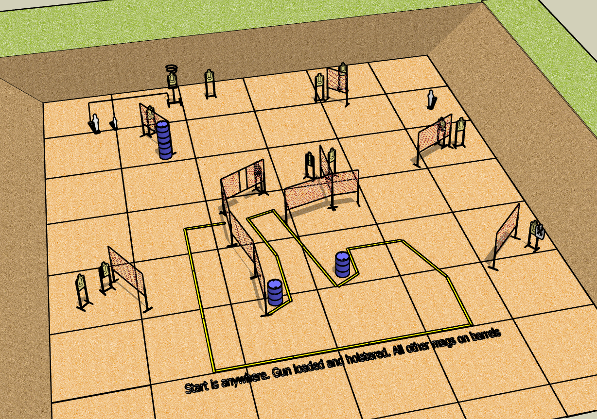

**Written Stage Briefing:**

**Stage 4 - The Battle of New Orleans –** is a 29-round, 145 point, Comstock Long Course. There are 13 cardboard targets and 3 steel targets. The best 2 hits per cardboard target will be scored. Steel must fall to score. The Drop Turn Target is NOT visible at rest.

**Start position** Anywhere, facing generally downrange.

**Handgun**: Loaded and holstered, wrists below belt.

**PCC**: Loaded, stock on belt, muzzle pointed at center of rear berm.

All additional magazines and reloading devices to be used during the stage must be placed on a barrel prior to the start signal.

On the audible start signal, engage targets from within the shooting area.

**Setup Notes:**

15 Single Wall Stands

3 Double Wall Stands

1 Triple Wall Stand

9 Full Walls

2 Half Walls

1 Ported Wall

12 Target stands / 24 Target Sticks

1 Drop Turn Target

2 Drop Turn Target Sticks

1 Activator Popper

2 Poppers

2 Popper Stands

4+ Barrels